CS624 Full-Stack Development Mobile App
PE02 – Core Components
Developed by Sam Chung on February 25, 2022
School of Technology & Computing (STC)
City University of Seattle (CityU)

Before You Start
- You already created a private GitHub repository for all your programming exercises, “cs624-pe-your_first_name.”
- You allowed your instructor and the Teaching Assistant to access your GitHub repository for programming assignments.
- The GitHub Codespaces may bill your account according to your usage. Check the price at https://docs.github.com/en/billing/managing-billing-for-github-codespaces/about-billing-for-github-codespaces.
- Some steps are not explained in the assignment. If you are not sure what to do:
  - Consult the resources listed in your course.
  - If you need help solving the problem after a few tries (~15 minutes), ask a TA for help.

Learning Outcomes
Students will be able to:
- Create a React Native mobile app using core components – View, Text, ScrollView, Image, TextInput, and StyleSheet.

Problem
Write a “CoreComponents” mobile app that will display MSCS courses with the following constraints:
- User Requirements
  - You can find the “icon.png” under the “./assets” directory.
  - You can enter your favorite course.
  - You display the 8 core, 2 depth of study, and 1 capstone course.
  - You can access the CityU’s catalog at https://cityu.smartcatalogiq.com/2022-2023/ay-2022-2023-catalog/.

- System Requirements
  - You must use an arrow function for the functional component.
  - You must use the core components at least once – View, Text, ScrollView, Image, TextInput, and StyleSheet.
  - Your screen is scrollable.
  - By using an internal style, the screen shows some styles.

For example, the following screen shows the outcomes.

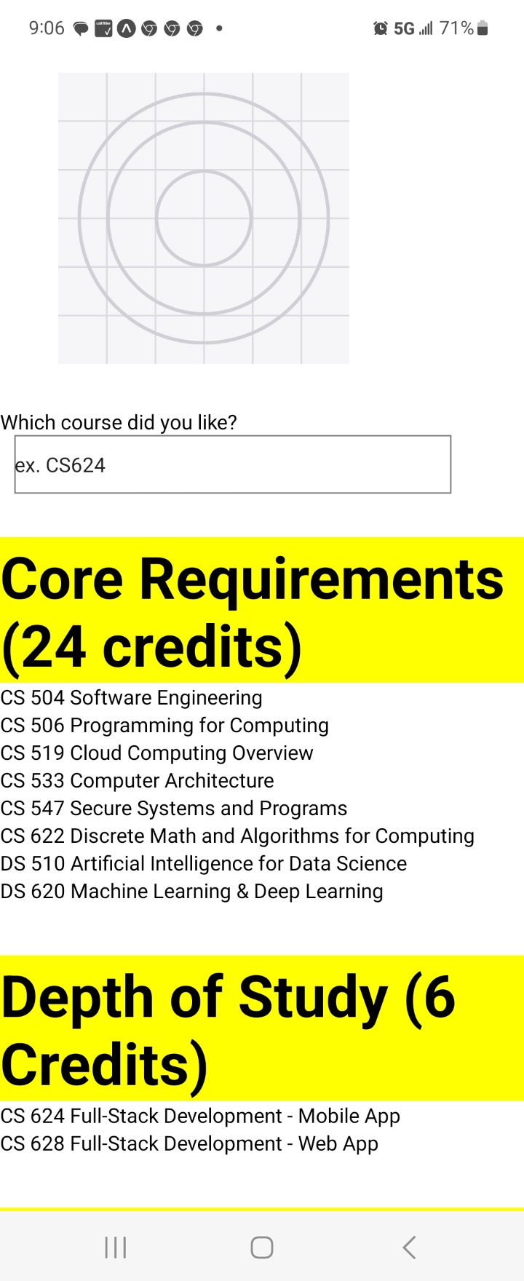

Submission
- If you already created a GitHub repository for your programming exercises, “cs624-pe-your_first_name,” create a directory for programming exercise 2, “PE02-CoreComponents.” For example, the screen below shows that the following seven directories were created for all programming exercises.

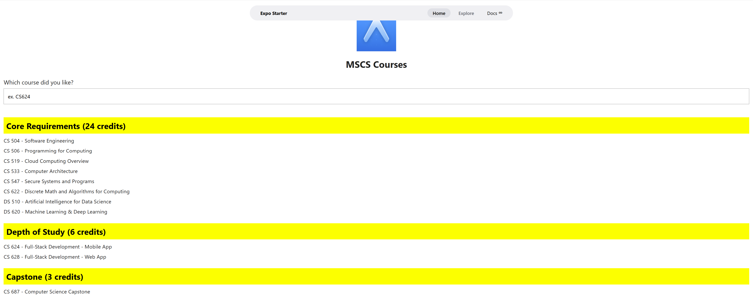

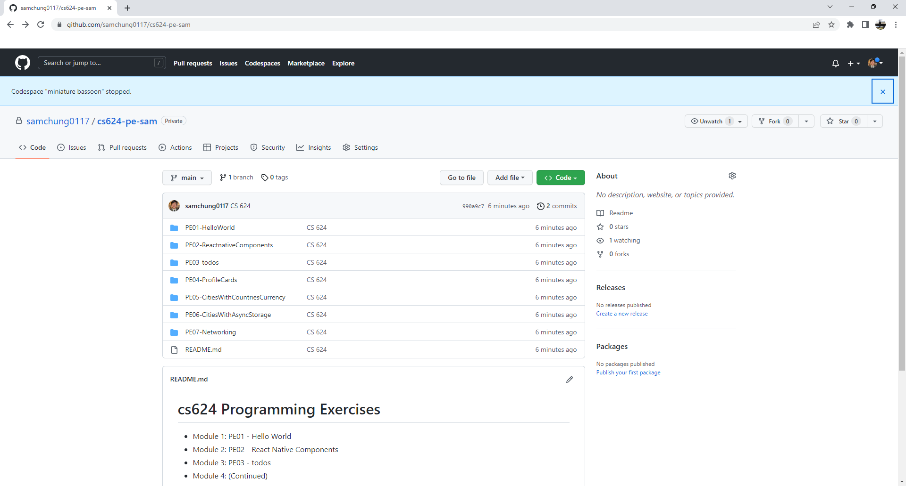

- Finish your programming exercise under the PE02 directory.
- Write a 150-word analysis report to explain how the program works in README.md regarding the input-process-output model. The README.md has three level-1 headings – Input, Process, and Output.
- Submit the link of your GitHub repository to your course shell through your assignment submission.

